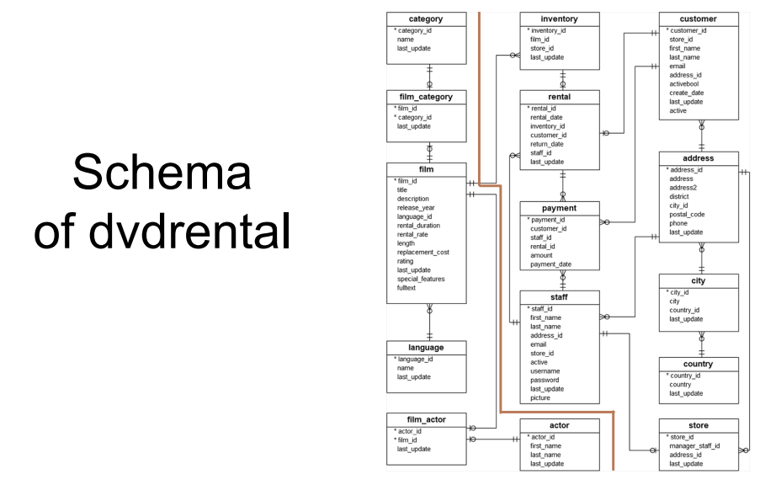

-- Find all categories assigned to more than one movie
select category_id
from film_category
group by category_id
having count(*) > 1

-- Find all categories assigned to more than one movie. SHOW THE NAME
select cat.name
from film_category as fc join
category as cat on
fc.category_id = cat.category_id
group by cat.category_id
having count(*) > 1

-- Find all categories assigned to more than one movie
select distinct fc1.category_id
from film_category fc1 join film_category fc2 on fc1.category_id = fc2.category_id
where fc1.film_id != fc2.film_id

-- for each category th total duration of all movies in that category
select cat.name, sum(f.length) as total
from film f join film_category fc on
f.film_id = fc.film_id join category cat on
cat.category_id = fc.category_id
group by cat.name

-- for each category th total duration of all movies in that category
select cat.name, sum(f.length) as total
from film f join film_category fc on
f.film_id = fc.film_id join category cat on
cat.category_id = fc.category_id
group by cat.name
order by total
REMEMBER: order by is the last command applied, so we can refer to tal (that is in the select)

-- for each category th total duration of all movies in that category. BUT ONLY WITH MORE THAN 7000 MIN
select cat.name, sum(f.length) as total
from film f join film_category fc on
f.film_id = fc.film_id join category cat on
cat.category_id = fc.category_id
group by cat.name
having sum(f.length) > 7000
order by total

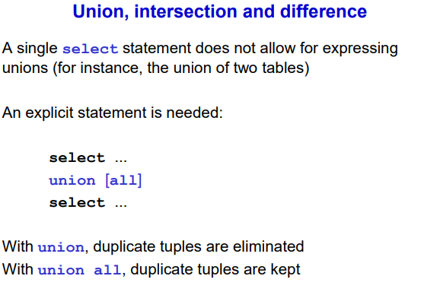
REMEMBER: for a union the two tables need to be union compatible (same number of attributes aka columns)

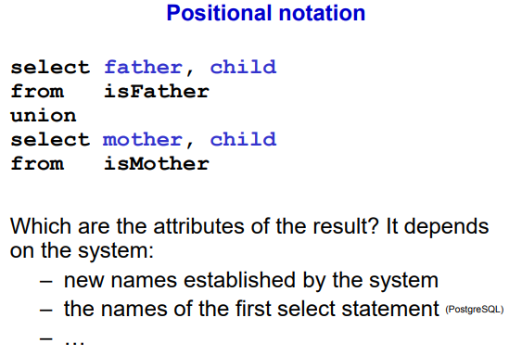

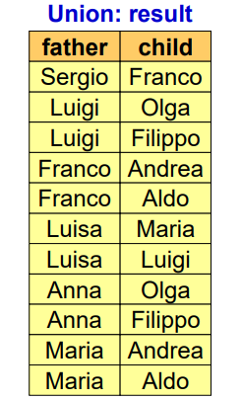

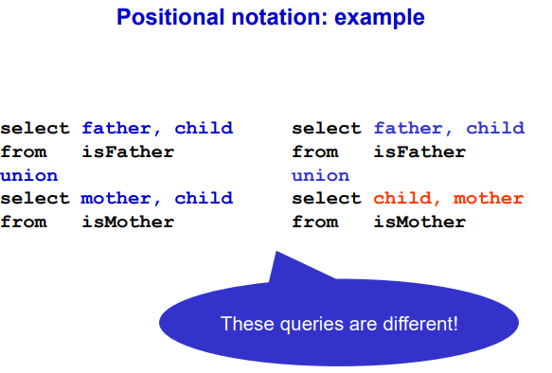
the results are different. We unite father and child.

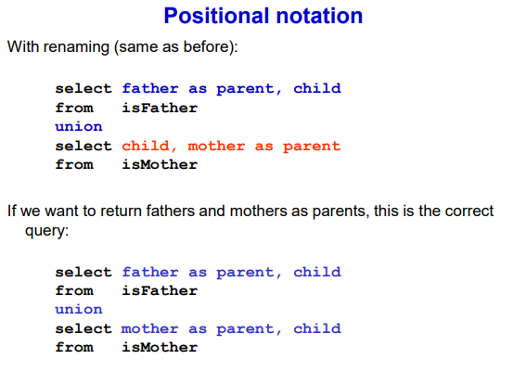
the union is row by row, you need to match (also conceptually) the two columns

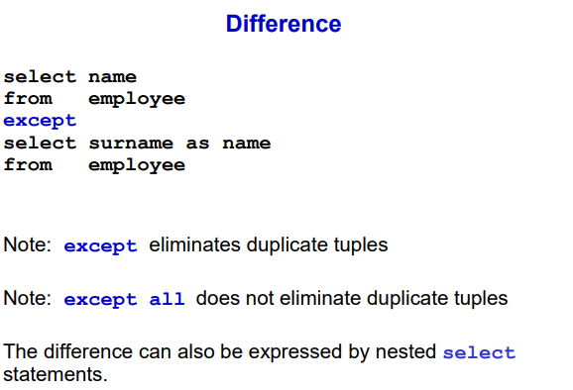
Difference is the same (must be union compatible)
Use the word except

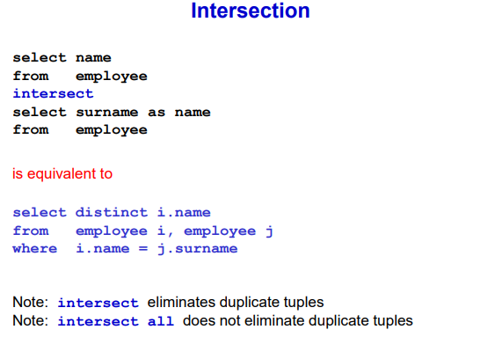
needs to be union compatible.

Intersection is a special case of the join where we keep the tuples that match on everything

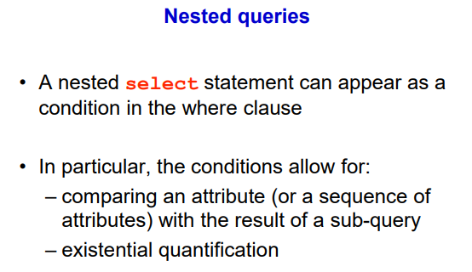
The where clause up to now is limited because can only check one tuple at time but sometimes you want to perform a more complex check (like checking if the name of a person is part of a certain list of people that we computed somewhere)

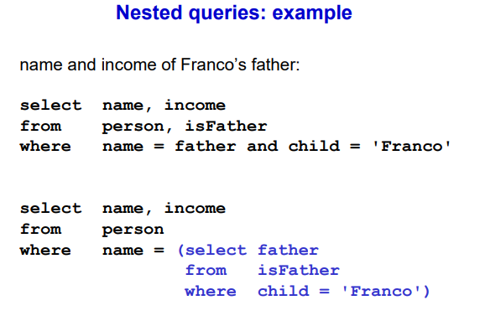
Another way to show better what is inside of the query is to use a nested query.

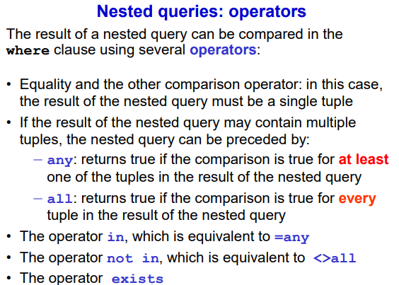
Might be interested only where the name of the person appears. Instead of equality you can write in

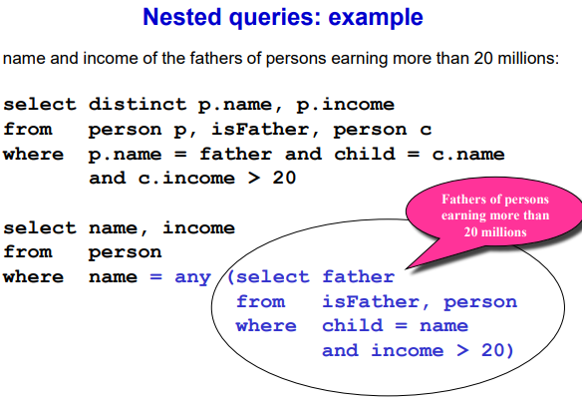

It is possible to do without nested query.

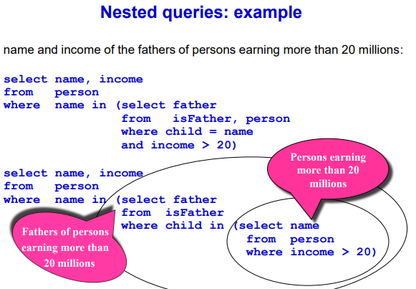
the goal of nested query is to simplify the structure of a query

